Compass and GPS Display (GPS Based) – CGEA1.3/FNV2

Functional Description

This document describes the interactions between instrument cluster and BCM for a GPS based compass. This STSS is not applicable to the LIN based compass.

The compass Display correlates the Operational_Mode and the GPS_Compass_direction signal, originating from the GPSM or APIM to display the directional heading of the vehicle as one of the following headings: North, Northeast, East, Southeast, South, Southwest, West, or Northwest. There is no need to Set Zone or to Calibrate.

In CGEA 1.3, there are 2 sub-architectures for SYNC. In SYNC Gen I and SYNC Gen II, there is a separate GPSM module. In SYNC Gen III, the GPSM is integrated into the APIM (SYNC) module. In both cases, the cluster receives compass data in ICAN message $466. Since the sources are different, and since the message transmit type is event (and not periodic), the cluster shall not log any compass missing messages.

Moving to FNV2 architecture, the CGEA 1.3 message $466 with the compass data is no longer supported. The cluster will receive either message $45E or $21E for Location Services. The cluster shall automatically configure the source of the compass data by looking first for presence of $466 (which will not exist in FNV2). If not found, then shall look at $45E and $21E for which message is populating compass direction. (i.e. whichever of those 2 messages populates Message Type parameter equal to 0x2 (Location2). Note that this is originally documented in the Location Service APIM SPSS, but is duplicated in this STSS for simplicity.

This STSS applies to CGEA and FNV2 programs that have decided to have the GPS based compass displayed in the cluster. This STSS applies to both the "B" display as well as 4.2" (or larger) LCD displays.

Some clusters have the option of showing a large magnetic ball compass or a 2-digit compass heading. When the magnetic ball display is selected, the 2 letter compass info is removed.

Starting with version 5.0, cluster will also display GPS coordinates (4 Decimal points) and Elevation (aka Altitude) with Compass Display. There is no update in CAN signals and cluster will use existing CAN signals to display this information. Lead program for this update is P708.

Interfaces

Interface Context Diagram (I/O Block Diagram)

Compass Context Diagram

Inputs

IR-REQ-301178/A-Internal
- Operational_Mode
- Compass_Sync_Cfg
- GPS_Display_Cfg
- Display_Units_MC

Mux Message from the CAN bus

SIG-REQ-301172/B-CAN Input Signal Details for GPS_Compass_direction

Signal Name | Size (bits) | Detail | Units | Res. | Offset | State Encoded | Min | Max
GPS_Compass_direction | 4 |  | SED | 1 | 0 |  | 0 (0x0) | 15 (0xF)
 |  | North |  |  |  | 0x0
 |  | NorthEast |  |  |  | 0x1
 |  | East |  |  |  | 0x2
 |  | SouthEast |  |  |  | 0x3
 |  | South |  |  |  | 0x4
 |  | SouthWest |  |  |  | 0x5
 |  | West |  |  |  | 0x6
 |  | NorthWest |  |  |  | 0x7
 |  | Not Used |  |  |  | 0x8 – 0xF

SIG-REQ-325944/A-CAN Input Signal Details for LocationServices_1.Location2.Compass Direction in FNV2
LocationServices_data1 in Message $45E or $21E:

The Location Service shall utilize a Global Navigation Satellite System (GNSS) multi-plex messaging protocol as defined below. The GNSS protocol shall utilize one or more data messages on the vehicle system interface that consists of 8 bytes of data. Each 8 byte block of data will represent one of 6 different messages:

- Meta Data/Time
- Location 1
- Location 2
- Location Quality
- Sensor Quality
- Sky View
- Location 3 (same as Location 1, but with shifted coordinates for China – only for China)
- Location 4 (RAW GNSS from Chipset)
- Location 5 (Map Match Feedback from embedded nav, if equipped)

Each of these 6 messages consists of several fields of data within the 8 byte blocks. The first field of data in every message is an 8 bit block called “Message Type” that indicates what fields of data are present in the remaining 60 bits of data. The Message Type Definition Table below defines the “Message Type” field used by all 6 messages.

Message Type | Message | Broadcast In
0 | MetaDataTime | LocationServices_Data1
1 | Location1 | LocationServices_Data1
2 | Location2 | LocationServices_Data1
3 | LocationQuality | LocationServices_Data1
4 | SensorQuality | LocationServices_Data1
5 | SkyView | LocationServices_Data2
6 | Location3 | LocationServices_Data1
7 | Location4 | LocationServices_Data1
8 | Location5 | LocationServices_Data1

GNSS Message Type: Location 2 (Note cluster only uses “Compass Direction” from this message when Message Type is 0x2 (Location2).

Data Field | Length  (bits) | Value  Range | Literals | Value | Description
Message Type | 4 | 2 | Location2 | 0x2 | See Message Type Definition Table.
Heading | 12 | 0 – 359.9 | 0 | 0x000 | Indicates the WGS84 Heading in degrees.
Heading | 12 | 0 – 359.9 | 0.1 | 0x001 | Indicates the WGS84 Heading in degrees.
Heading | 12 | 0 – 359.9 | … | … | Indicates the WGS84 Heading in degrees.
Heading | 12 | 0 – 359.9 | 359.9 | 0xE0F | Indicates the WGS84 Heading in degrees.
Mean Sea Level (MSL) Altitude  (Elevation/Altitude) | 11 | -1000 - 9000 | -1000 | 0x000 | Indicates the WGS84 altitude in meters.
Mean Sea Level (MSL) Altitude  (Elevation/Altitude) | 11 | -1000 - 9000 | -995 | 0x001 | Indicates the WGS84 altitude in meters.
Mean Sea Level (MSL) Altitude  (Elevation/Altitude) | 11 | -1000 - 9000 | … | … | Indicates the WGS84 altitude in meters.
Mean Sea Level (MSL) Altitude  (Elevation/Altitude) | 11 | -1000 - 9000 | -5 | 0x0C7 | Indicates the WGS84 altitude in meters.
Mean Sea Level (MSL) Altitude  (Elevation/Altitude) | 11 | -1000 - 9000 | 0 | 0x0C8 | Indicates the WGS84 altitude in meters.
Mean Sea Level (MSL) Altitude  (Elevation/Altitude) | 11 | -1000 - 9000 | 5 | 0x0C9 | Indicates the WGS84 altitude in meters.
Mean Sea Level (MSL) Altitude  (Elevation/Altitude) | 11 | -1000 - 9000 | … | … | Indicates the WGS84 altitude in meters.
Mean Sea Level (MSL) Altitude  (Elevation/Altitude) | 11 | -1000 - 9000 | 9000 | 0x7D0 | Indicates the WGS84 altitude in meters.
Velocity | 12 | 0.1 - 409.5 | 0 | 0x000 | Indicates the WGS84 velocity in kilometers per hour (kph).
Velocity | 12 | 0.1 - 409.5 | 0.1 | 0x001 | Indicates the WGS84 velocity in kilometers per hour (kph).
Velocity | 12 | 0.1 - 409.5 | … | … | Indicates the WGS84 velocity in kilometers per hour (kph).
Velocity | 12 | 0.1 - 409.5 | 409.5 | 0xFFF | Indicates the WGS84 velocity in kilometers per hour (kph).
Compass Direction | 4 | N/A | Null (Unknown) | 0x00 | Indicates compass direction.
Compass Direction | 4 | N/A | North | 0x01 | Indicates compass direction.
Compass Direction | 4 | N/A | NorthEast | 0x02 | Indicates compass direction.
Compass Direction | 4 | N/A | East | 0x03 | Indicates compass direction.
Compass Direction | 4 | N/A | SouthEast | 0x04 | Indicates compass direction.
Compass Direction | 4 | N/A | South | 0x05 | Indicates compass direction.
Compass Direction | 4 | N/A | SouthWest | 0x06 | Indicates compass direction.
Compass Direction | 4 | N/A | West | 0x07 | Indicates compass direction.
Compass Direction | 4 | N/A | NorthWest | 0x08 | Indicates compass direction.
GPS Satellites In Solution | 4 | 0 - 15 | 0 | 0x00 | Indicates the number of GPS satellites in solution.
GPS Satellites In Solution | 4 | 0 - 15 | 1 | 0x01 | Indicates the number of GPS satellites in solution.
GPS Satellites In Solution | 4 | 0 - 15 | … | … | Indicates the number of GPS satellites in solution.
GPS Satellites In Solution | 4 | 0 - 15 | 15 (or more) | 0xFF | Indicates the number of GPS satellites in solution.
GLONASS Satellites In Solution | 4 | 0 - 15 | 0 | 0x00 | Indicates the number of GLONASS satellites in solution.
GLONASS Satellites In Solution | 4 | 0 - 15 | 1 | 0x01 | Indicates the number of GLONASS satellites in solution.
GLONASS Satellites In Solution | 4 | 0 - 15 | … | … | Indicates the number of GLONASS satellites in solution.
GLONASS Satellites In Solution | 4 | 0 - 15 | 15 (or more) | 0xFF | Indicates the number of GLONASS satellites in solution.
Galileo Satellites In Solution | 4 | 0 - 15 | 0 | 0x00 | Indicates the number of Galileo satellites in solution.
Galileo Satellites In Solution | 4 | 0 - 15 | 1 | 0x01 | Indicates the number of Galileo satellites in solution.
Galileo Satellites In Solution | 4 | 0 - 15 | … | … | Indicates the number of Galileo satellites in solution.
Galileo Satellites In Solution | 4 | 0 - 15 | 15 (or more) | 0xFF | Indicates the number of Galileo satellites in solution.
Compass Satellites In Solution | 4 | 0 - 15 | 0 | 0x00 | Indicates the number of Compass satellites in solution.
Compass Satellites In Solution | 4 | 0 - 15 | 1 | 0x01 | Indicates the number of Compass satellites in solution.
Compass Satellites In Solution | 4 | 0 - 15 | … | … | Indicates the number of Compass satellites in solution.
Compass Satellites In Solution | 4 | 0 - 15 | 15 (or more) | 0xFF | Indicates the number of Compass satellites in solution.
Fix Type | 3 | N/A | Sensors Uncalibrated with no Fix (DR Off) | 0x0 | Indicates Fix type
Fix Type | 3 | N/A | Sensors Calibrated with no Fix (DR On) | 0x1 | Indicates Fix type
Fix Type | 3 | N/A | 2D Fix | 0x2 | Indicates Fix type
Fix Type | 3 | N/A | 3D Fix (DR Uncalibrated) | 0x3 | Indicates Fix type
Fix Type | 3 | N/A | 3D Fix DR Blended (DR Calibrated) | 0x4 | Indicates Fix type
Fix Type | 3 | N/A | 3D Fix DR Bleneded w DGPS (DR Calibrated) | 0x5 | Indicates Fix type
Note: All values outside the defined range above shall remain reserved.

The physical bit/byte position layout of the Location2 message is as follows: (Compass Direction is bits 44-47)

GPS Coordinate Information:

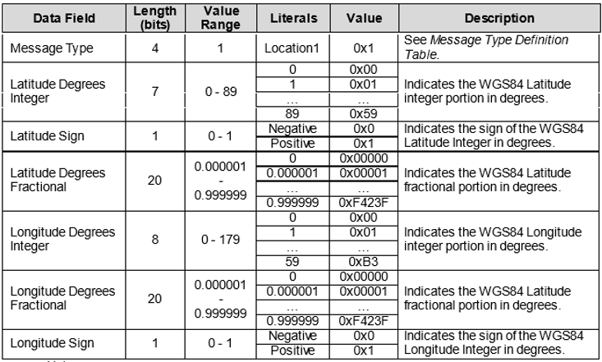

IR-REQ-301185/A-Outputs

- Compass_Display
- Magnetic_Ball_Display
- GPS_Display
- Elevation_Display

Function/Performance

F-REQ-301183/A-Operational Modes

Mode | Differentiating Vehicle Conditions
Sleep Mode | Compass/GPS/Elevation Function OFF
Limited Mode | Compass/GPS/Elevation Function OFF
Normal Mode | Compass/GPS/Elevation Function ON
Crank Mode | Compass/GPS/Elevation Function ON

Voltage Levels

Refer to the Cluster Features Table located in the Operational Modes and Voltage Range Strategies section of this SPSS.

Human-Machine Interface

Visual

Indicator Graphics / Display Format

Typical Graphics Showing A Compass Display
For High End Display (SHMI), refer to “<Program> Cluster Menu Structure.xls” and Program VAPS Model. A few typical graphics showing a compass display with letter headings are below.

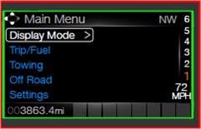

Typical Magnetic Ball Compass Display Graphics
Some typical magnetic ball compass display graphics are shown below:

HMI-REQ-301170/A-Magnetic Ball Or 2 Letter Compass
Some clusters have the option of showing a large magnetic ball compass or a 2 letter compass heading. When the magnetic ball display is selected, the 2 letter compass info is removed.

Fixed or Rotating North Programs
Some programs offer a menu choice of Fixed North or Rotating North:

Title: Compass
0 Fixed North
0 Rotating North

Example Graphic of Fixed North on left, Example of Rotating North on Right
Example Graphic of Fixed North on left, example of Rotating North on right:
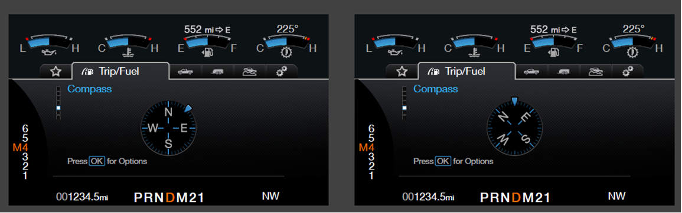
For "B" Display, refer to Text Message List – BEF Displays 2x14.xls, variable Legend

New Compass IOD screen with GPS information

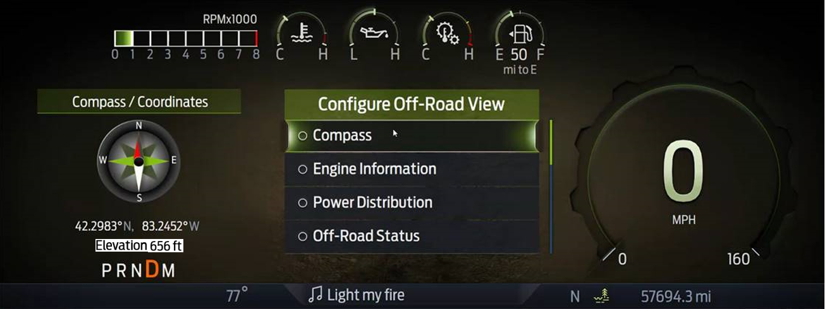
Elevation
GPS Coordinates
GPS Coordinates: Decimal Degree format (4 decimal points for accuracy)
Elevation: Display in Feet or Meter based on region.

Indicator Color Coordinates

Refer to Interior Lighting specification

Indicator Characteristics

Refer to Interior Lighting specification

Audio
None

Switch Control Logic
None

PFM-REQ-301184/A-System Accuracy
Within 100msec of receiving the CAN signal, the cluster shall update the Compass_Display value.

Operation: Performance and Functional

Subsystem Algorithm Flowchart / State Diagram

F-REQ-302627/B-Compass Display Diagnostic Flowchart

F-REQ-302628/B-GPS_Compass_direction lookup table if using Message $466 in CGEA 1.3

Operational_Mode | GPS_Compass_direction | Compass_Display | Magnetic_Ball_Display
Normal  Or  Crank | 0x0 | N | N
Normal  Or  Crank | 0x1 | NE | NE
Normal  Or  Crank | 0x2 | E | E
Normal  Or  Crank | 0x3 | SE | SE
Normal  Or  Crank | 0x4 | S | S
Normal  Or  Crank | 0x5 | SW | SW
Normal  Or  Crank | 0x6 | W | W
Normal  Or  Crank | 0x7 | NW | NW
Normal  Or  Crank | Declared missing or invalid | -- | Blanks
All other cases including never received |  | OFF (no display) | OFF (no display)
Notes:
- Due to the CAN signal being EVENT only (and not periodic), the “Declared missing or invalid” is Not Applicable. The CAN case for the CAN signal is out of range (0x8-0xF) falls under “All other cases including never received”.
- The compass display is only shown when Compass_Sync_Cfg = 0x1 (Present)

F-REQ-325959/A-Compass Direction lookup table if using Message $45E or $21E in FNV2

Operational_  Mode | Compass Direction | Compass_Display | Magnetic_Ball_Display
Normal  Or  Crank | 0x1 | N | N
Normal  Or  Crank | 0x2 | NE | NE
Normal  Or  Crank | 0x3 | E | E
Normal  Or  Crank | 0x4 | SE | SE
Normal  Or  Crank | 0x5 | S | S
Normal  Or  Crank | 0x6 | SW | SW
Normal  Or  Crank | 0x7 | W | W
Normal  Or  Crank | 0x8 | NW | NW
Normal  Or  Crank | Declared missing or invalid | -- | Blanks
All other cases including never received |  | OFF (no display) | OFF (no display)
Notes:
- Due to the CAN signal being EVENT only (and not periodic), the “Declared missing or invalid” is Not Applicable. The CAN case for the CAN signal is out of range (0x0, and 0x9-0xF) falls under “All other cases including never received”.
- The compass display is only shown when Compass_Sync_Cfg = 0x1 (Present)

F-REQ-398323/A-GPS Coordinates and Elevation using Message $45E or $21E

Operational_Mode | Compass_Sync_Cfg | GPS_Display  _Cfg | Location 1  Services Signal | Location 2  Services Signal | GPS_Display | Elevation_ Display
Normal  Or  Crank | 0x1  (Present) | 0x1  (Present) | Longitude/  Latitude | Elevation | GPS Coordinates  (Degree Decimal Display - 4 decimal points) | Elevation (Meters or Feet)
Normal  Or  Crank | 0x1  (Present) | 0x1  (Present) | Declared missing or invalid | Declared missing or invalid | -- | --
All other cases including never received |  |  |  |  | OFF  (no Display) | OFF  (no Display)

Operation Description (supports algorithm flowchart /state diagram)

F-REQ-301175/A-Operation Description Requirement 1

The electronic compass shall be operational when the ignition switch is in the RUN/START position only.

F-REQ-301176/A-Operation Description Requirement 2

The compass display is only shown when Compass_Sync_Cfg = 0x1 (Present)

F-REQ-301177/A-Operation Description Requirement 3

The compass display is NOT shown when Compass_Sync_Cfg = 0x0 (Not Present)

F-REQ-326156/A-Operation Description Auto Configure Requirement
- The cluster shall auto configure compass direction as follows:
  - First look for valid data in GPS_Compass_direction signal in message $466 (this can be skipped if already known that cluster is in a FNV2 architecture vehicle. Message $466 will not exist in FNV2 vehicle)
  - Shall monitor messages $45E and $21E bits 4 through 7 (Message Type). When the Message Type is equal to 0x2(Location2) the cluster shall use that CAN ID that transmitted the 0x2 as the Location Services data provider (source of compass direction). Note that on and FNV2 vehicle, only message $45E or message $21E will be populated, never both. The other signal shall be all zeroes.

F-REQ-398324/A-Elevation Displayed Value

Compass_Sync_Cfg | GPS_Display_Cfg | Display_Units_MC | Elevation_Display Units
Enabled | Enabled | English  (0x0 or 0x1) | Feet
Enabled | Enabled | Metric  (0x2 or 0x3) | Meter
Enabled | Disabled | X | Not Shown
Disabled | X | X | Not Shown

F-REQ-398325/A-Meter to Feet Conversion

Feet (Integer Value) = Round (Meter * 3.2808, 0)

Location 2 service signal is providing elevation (Mean Sea Level) information in ‘Meter’. IPC shall use standard ROUND function to display elevation integer value in Feet based on market preference.

FS-REQ-301186/A;1-Function Safety Classification (EMC)

Class B

NVM-REQ-301187/B-Memory Storage

Parameter Name | Description | Value at Battery Connect | Value at Module Wake-up
GPS_Compass_direction Signal | Input signal from CAN message $466 in CGEA 1.3 | 0x0 | 0x0
Compass Direction Signal | Input signal from either CAN message $45E or $21E in FNV2. | 0x0 | 0x0
Compass_Sync_Cfg | Config used when the compass information is from a GPS receiver (i.e. SYNC Gen I or Gen II or Gen III or later). When Present, the compass display is shown in the cluster. This must also be Enabled before Enabling GPS_Display or Elevation_Display”. | Do Not Init | Do Not Init
GPS_Display_Cfg | Config used when the GPS information is from a GPS receiver (i.e. SYNC Gen I or Gen II or Gen III or later). When Present, the GPS Coordinates and Elevation display is shown in the cluster. | Do Not Init | Do Not Init
Compass_Display | Output used to control the Compass values to be displayed | N | Do Not Init
GPS_Display | Output used to control the GPS Coordinates to be displayed | Do Not Init | Do Not Init
Elevation_Display | Output used to control the Elevation value to be displayed | Do Not Init | Do Not Init
North_Display_Fixed_Rotating | Battery Backed RAM variable for menu selection of Fixed North display or Rotating North Display. Default is Fixed North. | 0x0  (Fixed North) | Do Not Init
Magnetic_Ball_Display | Output used to control the Compass values to be displayed | N | Do Not Init
Operational_Mode | 4 state indicator for cluster operational mode | Limited | Limited or Normal or Crank

Prove Out
No

Reconfigurable Telltale
Not applicable.

Message Center Msg
Variables as defined in Text Message List – BEF Displays 2x14.xls

Error Handling

Missing Message Strategy

None. (Due to message being EVENT only)

Invalid Message Strategy

None. (Due to message being EVENT only)

Diagnostics

Self Test

None applicable - internal to Compass

Engineering Test Mode

None

Part II Performance

Supported Diagnostic Trouble Codes (DTCs)

DTC | Description
None

DCR-REQ-301182/B-Supported Configuration ($DExx) DIDs

Block  Num | Block Description | Size (bits) | Byte(s) | Bits | State: Description | "0" | "1" | Default | Comments/  Information
PACKETED BLOCKS
$00 | Option Content (B&A) | 1 | * | * | Compass Sync | Not Present | Present | Present | Set to 0x1 “Present” when compass data is to be displayed in cluster from a GPSM or APIM or TCU. Set to 0x0 for no compass display in cluster.
$0A | Option Content (B&A) | 1 | * | * | GPS Display | Not Present | Present | Present | Set to 0x1 “Present” when GPS Coordinates and Elevation is to be displayed in cluster from a APIM or TCU. Set to 0x0 for no GPS Coordinates and Elevation in cluster.
*Byte and bit location to be identified in Part II Specification for this cluster

Reference Specification

IS-0280 Compass performance (Version 3)
instrum sds instrumentation subsystem (version 26)
Compass w/cid stss (VERSION 4.0 6/16/2006)

Revision History

SPSS Module Revision History

Revision Level | Name | Change Description | Date
1.0 | V.Patel | Updated for CGEA 1.3 based on CGEA STSS v1.0  Section 1.2.2 – Removed table referencing the HS-CAN message that contains the input signal.  Section 1.4 – Rewritten. Deleted references of specific missing message and invalid data flags and timers.  Section 1.5.3 – Deleted DTC logging criteria from table. | 4/7/2010
1.1 | S. Watkins  M. Hakim | General cleanup and DTC update. Details are as follows:  Updated DE00 to DExx all throughout the document.  Section 1.1: Updated the Functional Description sentence that is dealing with the input signal and its source.  Section 1.2.1: Context Diagram: Replaced the input signal with the correct one.  Updated the function name to “Compass Display.”  Section 1.2.2: Added the configurations to the inputs.  Section 1.2.3: Added the Magnetic_Ball_Display output and removed the description of the Compass_Display  Section 1.3.1 – Added CRANK as compass ON.  Section 1.3.4: Corrected typos for the Compass_Display output name.  Section 1.3.5.1: Added Figure 2 Compass Diagnostic Flowchart, and updated the decision diamond with the correct wording.  Section 1.3.5.4: Removed the table title and added the outputs to the Memory Storage table.  Section 1.5.3: Corrected the Lost Communication DTC to be logged against the GPSM module with the correct DTC number.  Updated document footer. | 9/17/2013
1.2 | T. Cwik | Continuation of General Cleanup.  Section 1.3.5.1: Table 2 - Changed Operational_Mode to “Normal or Crank” | 11/13/2013
2.0 | S. Watkins | To prepare for SYNC Gen3, we are removing DTC’s and clarifying usage of the Compass_Sync_Cfg bit. Also, continued general clean up.  In summary, only functional change is to delete compass DTC’s.  - Section 1.1 – Updated description  - Section 1.3.5.1, Table 2 – Struck out “Missing or Invalid” row and added 2 notes below table.  - Section 1.3.5.2 – Added 2 bulltet points to clarify that there is no compass display when configured “not present”.  - Section 1.3.5.4 – Added Compass_Sync_Cfg description  - Section 1.4.1 – Deleted missing message strategy  - Section 1.4.2 – Deleted invalid message strategy  - Section 1.5.3 – Deleted 2 DTC’s and updated description in $DExx. | 7/23/2014
3.0 | S. Watkins | NO NEED TO DCR THIS ON ANY PROGRAM  Cleanup per Denso Q&A #302.  The F-Series trucks off the HMI choice of “Fixed North” or “Rotating North” for the compass display. This was simply a menu pick kept in battery backed RAM in the cluster, but was not mentioned in this STSS. Thus, I am adding it.  - Section 1.3.3.2 – Added Menu and examples of Fixed North / Rotating North  - Section 1.3.5.4 – Added North_Display_Fixed_Rotating parameter to Table. | 10/14/2016
3.1 | A. Mufid | Initial VSEM RM Release | 3/13/2018
4.0 | S. Watkins | This needs to be DCR’d for FNV2 architecture programs.  Moving to FNV2 architecture, the CGEA 1.3 message $466 with the compass data is no longer supported. The cluster will receive either message $45E or $21E for Location Services.  Changes in turquoise:  - Section 1.0 – Added FNV2 to the title  - Section 1.1 – Added description  - Section 1.2.1 – Added LocationServices_1.Location2.Compass Direction  - Section 1.2.2.2.2 – Added data for new CAN signals $45E or $21E  - Section 1.3.5.1.2 – Added “if using Message $466 in CGEA 1.3” to title.  - Section 1.3.5.1.3 – Added new “Compass Direction lookup table if using Message $45E or $21E in FNV2” table.  - Section 1.3.5.2.4 – Added automatic configuration rules  - Section 1.3.5.4 – Added Compass Direction Signal to table  - Section 1.5.3.2 – Added “or TCU”. | 8/22/2018
4.1 | A. Mufid | Fixed broken requirements and charts | 9/28/2018
4.2 | A. Mufid | Updated Paragraph 516642 Visio Figure | 9/8/2019
5.0 | H. Sharma | This request was brought to DICC by Andrew Brown and approved for STSS update on 07/16/200. Changes are marked in Orange color.  DICC tracking # 572  Lead Program: P708 MY23  - Section 1.2.1 Interface Context Diagram is updated to add new GPS configuration and GPS/Elevation output signal.  - Section 1.2.2.1 IR-REQ-301178/A-Internal is updated to add new GPS configuration.  - Section 1.2.2.2.2 SIG-REQ-325944 is updated to add GPS related information. (NO change in CAN signal, this is updated only for reference)  - Section 1.2.3 IR-REQ-301185/A-Outputs is updated to add GPS_Display and Elevation_Display as output.  - Section 1.3.1 F-REQ-301183/A-Operational Modes is updated to add GPS/Elevation as output.  New section 1.3.3.1.1.6 New Compass IOD screen with GPS information is added.  - Section 1.3.5.1.1F-REQ-302627/B-Compass Display Diagnostic Flowchart is updated to add GPS Display configuration.  New section 1.3.5.1.4 F-REQ-398323/A-GPS Coordinates and Elevation using Message $45E or $21E is added  - Two new sections 1.3.5.2.5 and 1.3.5.2.6 are added for Elevation display.  Section 1.3.5.4 NVM-REQ-301187/B-Memory Storage is updated to add GPS Display config  Section 1.5.3.2 DCR-REQ-301182/B-Supported Configuration ($DExx) DIDs is updated to add GPS Display config | 09/15/2020

